**Project Design Phase-I Solution Architecture**

|  |  |
| --- | --- |
| Date | 09 OCTOBER 2022 |
| Team ID | PNT2022TMID22495 |
| Project Name | Project – Smart Fashion Recommender Application |
| Maximum Marks | 4 Marks |

**Solution Architecture:**

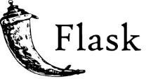



User

Explores the website



Chooses product

User Satisfied

?

Yes

User interface

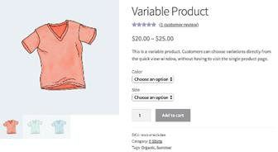

Information Resources

Product details

Website

Recommendation

Chatbot

No



Delivery

Shipment

Payment Options